**PRACTICAL NO: 4**

**Aim: Capturing and analyzing network packets using Wireshark (Fundamentals):**

**- Identification the live network**

**- Capture Packets**

**- Analyze the captured packets**

1. **Capture packet that have http protocol.**

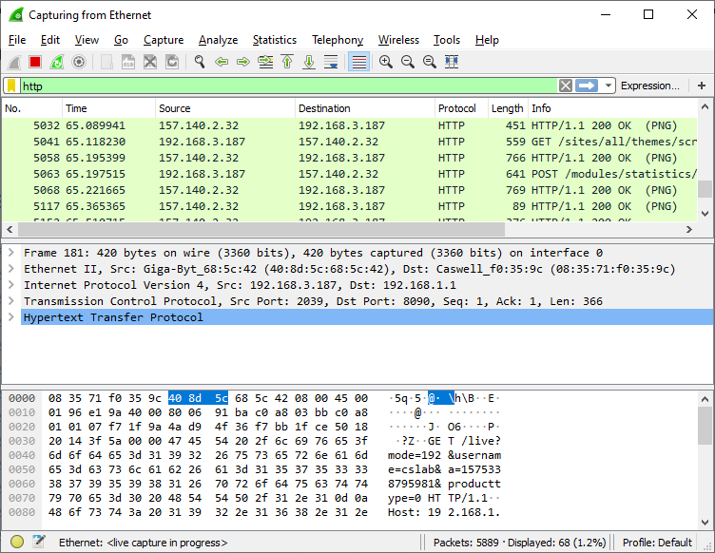

1. **Capture packet that have a status 200**

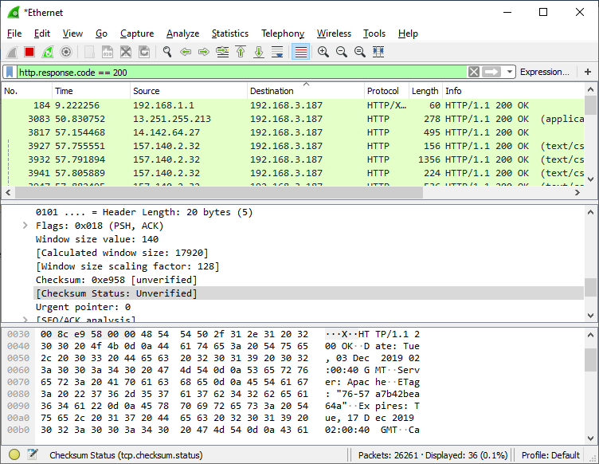

1. **Analyse any one tcp packet.**

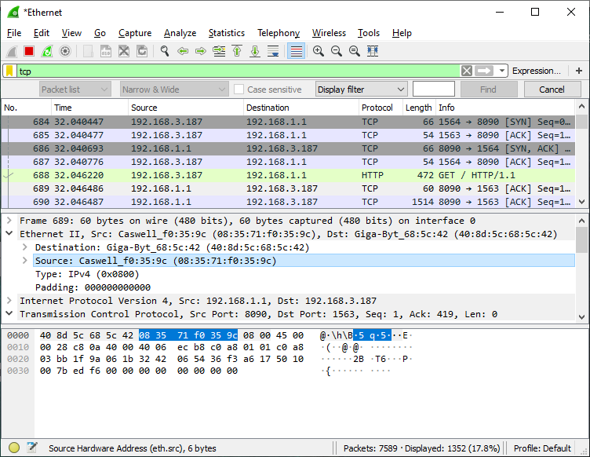

**4.analyse an ftp packet and note its host.**

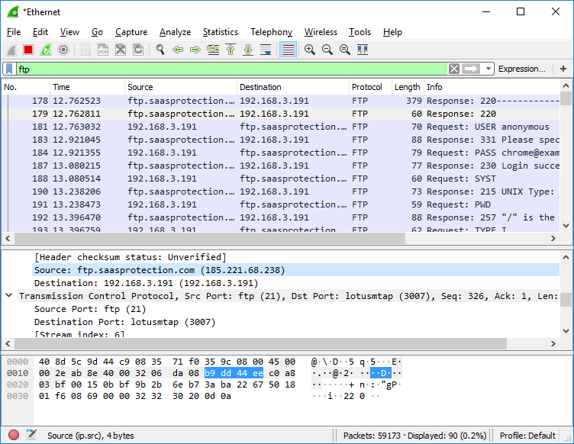

1. **Save the capture packets as a pcap file.**

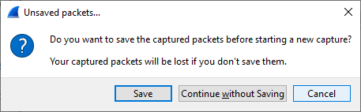

Click on Save.

